**THIS IS THE INSTRUCTION FOR USING OUR WEBSITE**

*\*Using 1366 x 768 resolution for the best experience (not included the scollbar on the side).*

1. **Using “Index.html” to access to our website.**

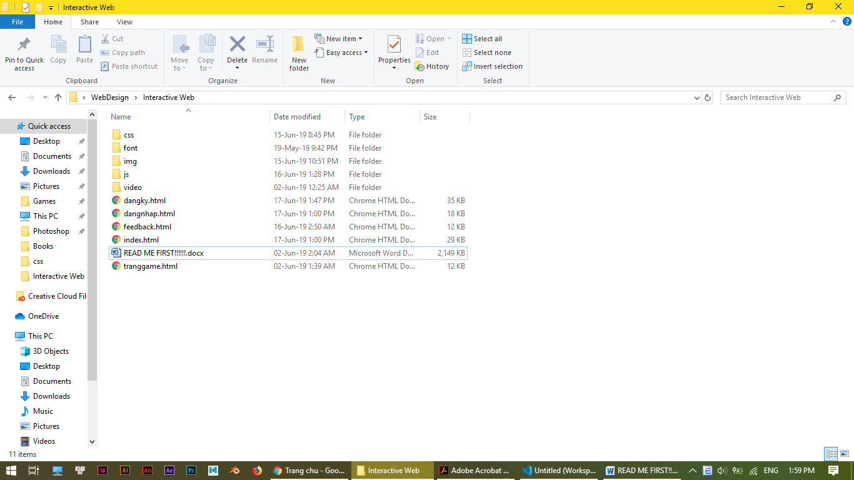

1. **Now you can explore our website by using shortcut on primary page**

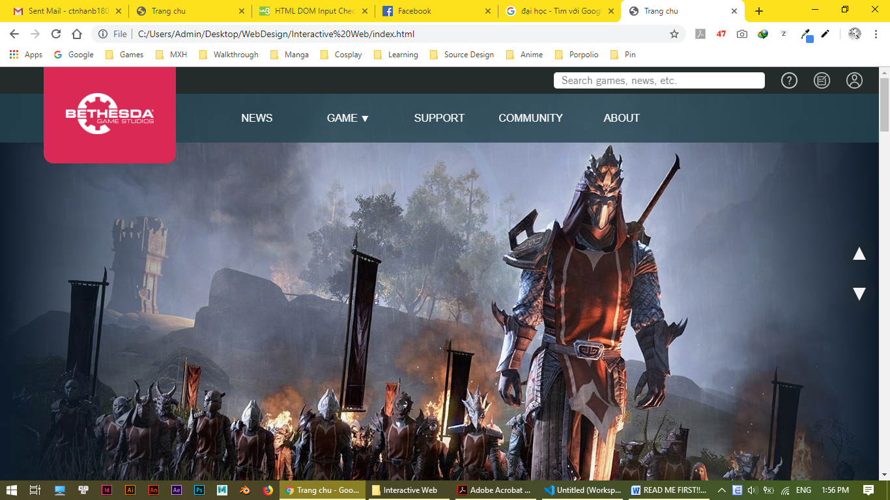

Trang game chi tiet

Log In / Sign In

Feedback

Trang chu

1. **In the “dangnhap.html” page, the button 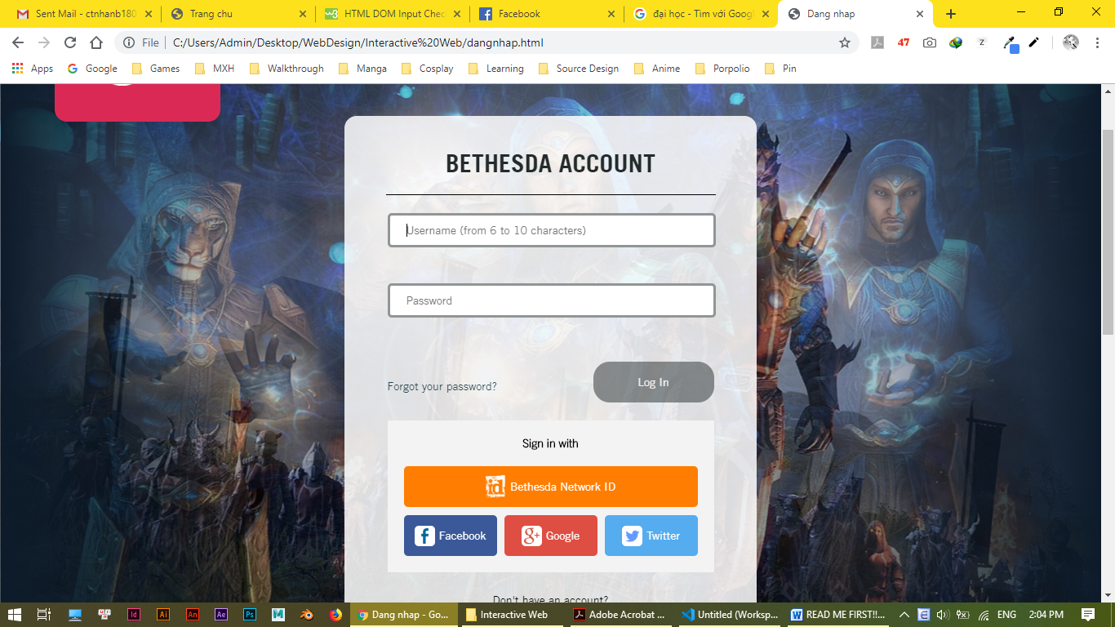 only active when you enter all information above.**

